Optical Repeater

💡 What is an Optical Repeater?
# Source: AI Source: Provided by: [Data Path: Persons Table -> ID Column: 1, Name_En Column: Motasem Essam] -> From: [ChatGPT] on [12/18/2025]
An Optical Repeater is a device used in fiber optic communication systems to boost and regenerate optical signals that have weakened or degraded over long distances. It enables high-speed data transmission across hundreds or thousands of kilometers by restoring signal strength and quality without converting light back to electricity (in most cases).
✅ It’s the fiber optic equivalent of a traditional repeater — but works with light signals instead of electrical ones.

📶 Why It's Needed
# Source: AI Source: Provided by: [Data Path: Persons Table -> ID Column: 1, Name_En Column: Motasem Essam] -> From: [ChatGPT] on [12/18/2025]
Fiber optic cables carry data as pulses of light. Over long distances, these signals lose intensity due to:
- Attenuation (signal loss)
- Dispersion (signal spreading)
- Noise and distortion
An optical repeater helps maintain signal integrity over such distances.

🧱 Where It’s Used
# Source: AI Source: Provided by: [Data Path: Persons Table -> ID Column: 1, Name_En Column: Motasem Essam] -> From: [ChatGPT] on [12/18/2025]
- Undersea fiber optic cables
- Long-haul telecom backbones
- Inter-city fiber connections
- Metro or regional optical networks

🔄 Types of Optical Repeaters
# Source: AI Source: Provided by: [Data Path: Persons Table -> ID Column: 1, Name_En Column: Motasem Essam] -> From: [ChatGPT] on [12/18/2025]
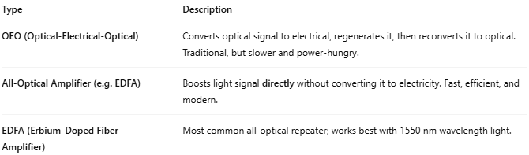

Type | Description
OEO (Optical-Electrical-Optical) | Converts optical signal to electrical, regenerates it, then reconverts it to optical. Traditional, but slower and power-hungry.
All-Optical Amplifier (e.g. EDFA) | Boosts light signal directly without converting it to electricity. Fast, efficient, and modern.
EDFA (Erbium-Doped Fiber Amplifier) | Most common all-optical repeater; works best with 1550 nm wavelength light.

🔧 Key Components in an OEO Repeater
# Source: AI Source: Provided by: [Data Path: Persons Table -> ID Column: 1, Name_En Column: Motasem Essam] -> From: [ChatGPT] on [12/18/2025]
- Photodetector – Converts light to electrical signal
- Signal Regenerator – Cleans, reshapes, and re-times (3R) the signal
- Laser Transmitter – Converts back to light and sends onward
⚡ In contrast, an EDFA just amplifies the light using a special fiber and a laser pump — no conversions.

🧠 3R Functionality (in advanced repeaters)
# Source: AI Source: Provided by: [Data Path: Persons Table -> ID Column: 1, Name_En Column: Motasem Essam] -> From: [ChatGPT] on [12/18/2025]


R | Meaning | Description
1 | Reamplify | Boost the power of the signal
2 | Reshape | Clean up waveform distortion
3 | Retime | Correct signal timing (jitter)

✅ Pros
# Source: AI Source: Provided by: [Data Path: Persons Table -> ID Column: 1, Name_En Column: Motasem Essam] -> From: [ChatGPT] on [12/18/2025]
- ✅ Enables ultra-long-distance fiber links
- ✅ Maintains signal strength without retransmission
- ✅ Modern repeaters (like EDFAs) are fast and low-latency
- ✅ All-optical types reduce power consumption and complexity

❌ Cons
# Source: AI Source: Provided by: [Data Path: Persons Table -> ID Column: 1, Name_En Column: Motasem Essam] -> From: [ChatGPT] on [12/18/2025]
- ❌ Expensive to deploy and maintain
- ❌ Requires precise wavelength and signal control
- ❌ OEO models introduce delay and are energy-intensive

📌 Summary
# Source: AI Source: Provided by: [Data Path: Persons Table -> ID Column: 1, Name_En Column: Motasem Essam] -> From: [ChatGPT] on [12/18/2025]


Feature | Optical Repeater
Purpose | Boost/restore weakened light signals in fiber cables
Works On | Layer 1 (Physical Layer)
Used In | Long-distance fiber links (e.g., undersea cables, telecom backbones)
Modern Type | EDFA (All-optical amplifier)

